|  |
| --- |
| DATA VISUALIZATION USING TABLEAU |
| ASSIGNMENT 6 |
| November 20, 2022**.**  INDIANA UNIVERSITY (BLOOMINGTON)  Authored by: VARSHA R IU ID: 2000751388 Sem: Fall 2022 |

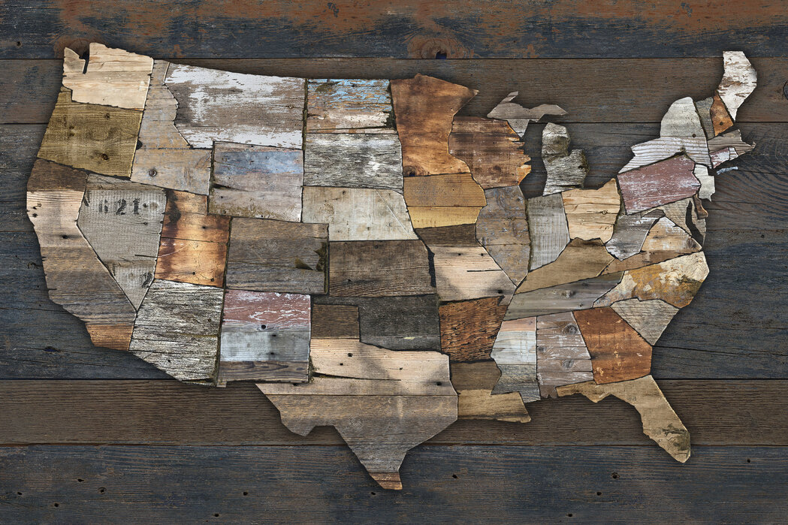

# Introduction

|  |
| --- |
| Data visualization is achieved using Tableau, a software package focusing on business intelligence (BI). The word tableau refers to a graphic representation or description. As a novice with Tableau, I have experimented with the software and tried to replicate a visualization available in the tableau public repository. I have tried to implement some of my learnings from this tableau course to replicate the already existing visualization and additionally have learnt a few things that was required to replicate to the highest accuracy. The purpose of this report is to discuss the replication approach and procedure I took for this assignment. What is the workbook about? **Title: State Rankings – Fall 2022**  Hospitals across the country show a lot of variation when it comes to patient safety. The leapfrog hospital safety grade assigns and A, B, C, D or F letter grade to nearly 3000 general acute care hospitals in the USA. It is the only rating focused on our hospitals ability to protect patients from preventable errors, accidents, injuries, and infections. States are ranked based on the percentage of A hospitals they have in their state. The workbook that I selected uses these ranks data to plot a geographical heat map to portray the same. The heat map shows which states have the highest (darker green) and lowest (lighter green) percentages of A ranked hospital. Why did you find it interesting? Studying about a nation that I reside in and gaining more knowledge about it has always been interesting to me. When I came across this visualization, I was curious to know which are the highest and lowest ranking states when it comes to medical safety and when I researched more about the workbook, I found it to be the right level of difficulty in replicating it based off what we have learned so far in our course on tableau. The workbook not only covered the elements that we learned in this course but also required me to study more features of tableau which I will explain in detail later in the report. Dataset **Source:** [**https://www.hospitalsafetygrade.org/state-rankings**](https://www.hospitalsafetygrade.org/state-rankings)  For the visualizations, we will use a dataset that contains around a year’s worth of hospital safety grade rankings. “The Leapfrog Group” is a national nonprofit organization driving a movement for giant leaps forward in the quality and safety of American healthcare and it was founded in the year 2000. The members of this organization are the collectors of this data set. The original visualization I was trying to replicate had the link to the website where this visualization was being used and I found the data table from this website. Out of spring 2022 and fall 2022 dataset that were available on the website, I extracted the fall 2022 since the visualization uses the same. Since the data on the website was in a tabular format, I had to copy-paste it to a new excel file and turn it into a usable dataset. The image below shows a snippet of how the dataset looks on the website (the data we are using for replicating the visualization).  Table  Description automatically generated |

# What new things did you learn from workbook about tableau:

At first when I started replicating the visualization, I was doubting if it will serve to be a challenge considering it is just a simple geographical heat map. But I am glad I kept going as I stumbled across a lot of challenges. Let us now discuss the things I had to learn and figure out while trying to replicate the visualization. I captured screenshots of all the before and after views of my tableau workbook to show what was the things I did not know and how I implemented the same after I learnt it on my own.

1. **Removing unnecessary contents from the geographical map** – At first while you plot the states in the map area, it does show the 50 states but also shows the background content such as other country boundaries, terrains, coastlines, names and labels, etc. The original visualization does not have any kind of contents except for the US states map. I learnt how to remove all the unnecessary contents to replicate the original.

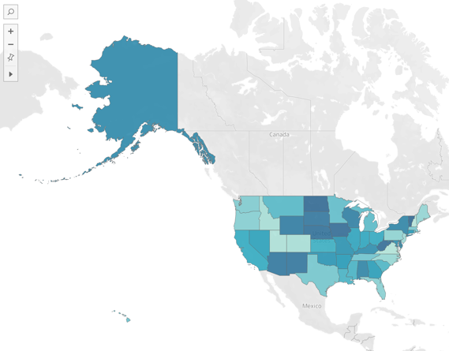 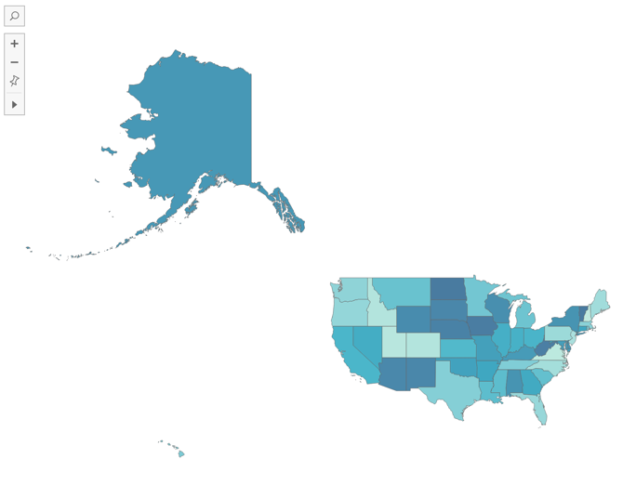

1. **Matching the color palette** – This was the most challenging part of the replication procedure. Default tableau color palettes did not have the one that was used for the original visualization. Therefore, I had to dig deep into it and find various ways on how to create a custom color palette. I came across a method in which you code the html color codes into the tableau repository preferences file (.tps file). I used the following website to try and get the accurate html color codes from the original visualization image to create the palette: <https://imagecolorpicker.com/en>

Before and after editing the .tps file with html color codes for custom sequential palette:

Default green color palette vs custom green color palette:

# Tooltip – Even though we have already learned about tool tip during our course, working on this project while trying to replicate the original visualization was when I got to play around with tooltip and implement a lot of features related to the same. I learned various ways how tooltip can be used and edited according to the visualization needs.

# Fitting Alaska and Hawaii close to other states – I had to create 3 different sheets, i.e., Continental US, Alaska and Hawaii to be able to show them clustered close together.

# 

# Creating floating dashboard – Learning about floating features in the dashboards to float one visualization above the other was really fun. I used this feature to place Alaska, Hawaii, and the sequential color legend to match the positions of the original visualization.

# How much were you able to replicate it?

# Original visualization:

# Replicated visualization:

I could replicate every single sheet without missing out any chunk of the visualization. Breakdown of my sheets and its similarity and accuracy compared to the original final visualization are as follows:

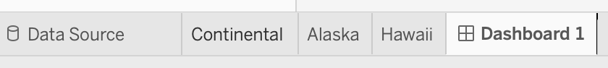

**Sheet 1: Continental US map**

This sheet contains all continental states of US. This sheet also contains the custom sequential color legend that is shown in the final visualization. The color palette in the legend matches the original tremendously.

Things that are a little different from the original from my sheet 1:

* The saturation of the colors is slightly higher in my visualization compared to the original even though the custom color palette I created looks exactly like the original.
* The map is slightly curved on the top in the original whereas in mine it is not. I do not think this affects the portrayed data anyhow, but I considered mentioning it since the goal was to replicate a visualization.

**Sheet 2: Alaska map**

This sheet contains the Alaska state. This part of the visualization has accurately been replicated when it comes to color, isolation, labeling, data, etc.

Things that are a little different from the original from my sheet 2:

* Alaska is a little tilted in the original visualization.

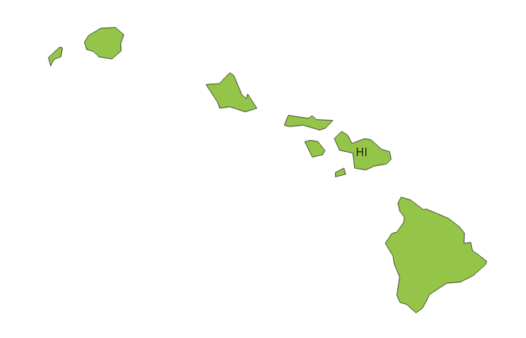**Sheet 3: Hawaii map**

This sheet contains the Hawaii state. This part of the visualization has accurately been replicated when it comes to color, isolation, data, etc.

Things that are a little different from the original from my sheet 2:

* Hawaii is a little tilted in the original visualization.

**Dashboard: Final replicated visualization**

The dashboard contains the replicated visualization. The replicated visualization is around 85% similar to the original visualization created by the leapfrog group.

